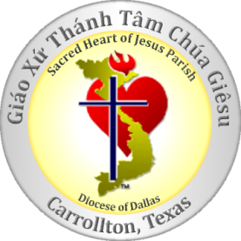

Registration for Youth Rally 2014
Name: ____________________________________________________________________________

Age: ______________________________________________________________________________
Parent Name (if under 18): ____________________________________________________________
Phone: ____________________________________________________________________________

Email: _____________________________________________________________________________
Emergency contact
Name: _________________________________Phone: _____________________________________
  Fee for Youth Rally: $10
PARENTAL PERMISSION FOR EMERGENCY TREATMENT
In the event of illness or accident, I give my permission for emergency treatment by qualified medical personnel for my children.

RELEASE OF LIABILITY
Although the safety of all participants is the primary concern of the Youth Rally organizers, many indoor and outdoor activities presents certain risks of injury. I expressly assume the risk of injury or illness arising from any cause, and agree to waive the right to pursue any claim against the Sacred of Jesus Catholic Church and the Retreat organizers.
I agree to permit my child to attend the Youth Rally 2014 as described above.

Signature _________________________________ Date __________________________________

*** Contact Information ***
Hai Hoang: hoanght82@yahoo.com or 504-338-3881
Vuong Tran: johnnyvuongtran@gmail.com or 469-855-5388

